Assessment Literacy and Feedback Survey Report
Sophie Marshall, July 2023
Preliminary considerations 2
Response demographics 3
General student views on a variety of different sources of feedback 4
Q1: For each of the following sources of feedback, how much do you use them? 4
Q2: For each of the following sources of feedback, please rate the quality of the feedback you received. 4
Q3 & Q4: Written responses of positive and negative views of different sources of feedback 4
Piazza 5
PASS 5
Blackboard Quizzes 5
Peers 6
Written feedback & marks on coursework, midterms and problem sheets 6
Videos & worked solutions 7
Supervisions & Tutorials 7
General exam feedback 7
Lecture Notes & written resources 8
Office hours 8
Q10: How often do you go to staff office hours? 9
Q10 Continued: Do any of the following make you less likely to go to office hours? (Check all that apply) 10
Model solutions 10
Q14.1-3: Please indicate your agreement with the statements 11
Q12: How often do you feel confident judging the quality of your work without help from staff or peers? 11
Q13: Regarding problem sheets which you are expected to mark yourself using model solutions, when would you prefer the solutions to be released? 13
Emotional wellbeing and mental health 15
Q16: In general, how often does the feedback you receive make you feel motivated to improve? 15
Q17: How does the feedback you receive impact your emotional wellbeing and mental health? Is there anything we can do to improve this? 16
Some general feedback views 17
Q6.1: I have enough opportunities to discuss and clarify the feedback I receive with teaching staff 18
Q6.2: In general, feedback from staff arrives soon enough to help with the next assessment 18
Q6.3: In general, I am satisfied with how detailed my feedback from staff is 18
Q6.4: Throughout a module, I am given sufficient feedback opportunities about my general progress 19
Q8: Under what circumstances are you likely to review written feedback? 19
Q7: When you receive feedback from teaching staff, what do you find the most useful? 20
Q11: If you could improve some aspect of the feedback you receive, what would be the most important aspect to improve? 20
Q18: In general, is there anything more that we could do to improve your experience of assessment and feedback? Do you have any further comments relating to assessment and feedback? 21
Concluding thoughts 22

Preliminary considerations

Readers of this report should note that the sample size for each question may vary, as 13 of the 76 responses did not finish the survey, but still completed enough questions for their responses to be included. The criteria for inclusion was answering up to at least Q1 & Q2, which ask students to indicate the frequency of use and quality of different forms of feedback. 11/13 incomplete responses only answered Q1 & Q2, while a further 2 incomplete responses answered up to Q10, which asks students how often they attend office hours.

Of the original 156 responses, 77 had completed only introductory questions and were deleted. A further 3 responses did not consent to the privacy and data terms, so were also deleted, leaving a total of 76 usable responses.

To encourage survey retention, all open-ended (write in) questions were optional. All multiple-choice questions were compulsory to progress in the survey. Therefore, all quantitative results are representative of all the surveyees (apart from those few incomplete responses who did not get that far in the survey), while all written responses represent the views of only those students who chose to share their views. Specific written responses have been handpicked based on interest. Some written responses have been edited for grammatical correctness and clarity. Similarly, the wording of some survey questions have been edited for clarity in this report. A full list of the survey questions is available upon request.

Quantitative results will be broken down by “Most recent year of study” and “Current working grade”. In each case, some data is excluded from the breakdown.
- Due to a small sample size of only 3 responses, 4th year students were excluded from breakdowns by year of study. Responses from 4th year students were still included in the rest of the survey analysis.
- While “Foundation year” was an option, no responses of this kind fulfilled the criteria for inclusion in the results.
- When asked about their grades, students were offered the option to answer “Not sure/Prefer not to say”, which 12.7% of surveyees selected. These students’ responses have been excluded from any breakdown by current working grade.

It should be noted that this survey was conducted during the summer holiday period for undergraduate students. While the number of responses was promising, all results of this survey should be interpreted with caution as they come from only those students who are sufficiently engaged with university communication to complete a survey during a break, as well as to be checking their emails and other communication channels during the holidays.

Response demographics
Year group
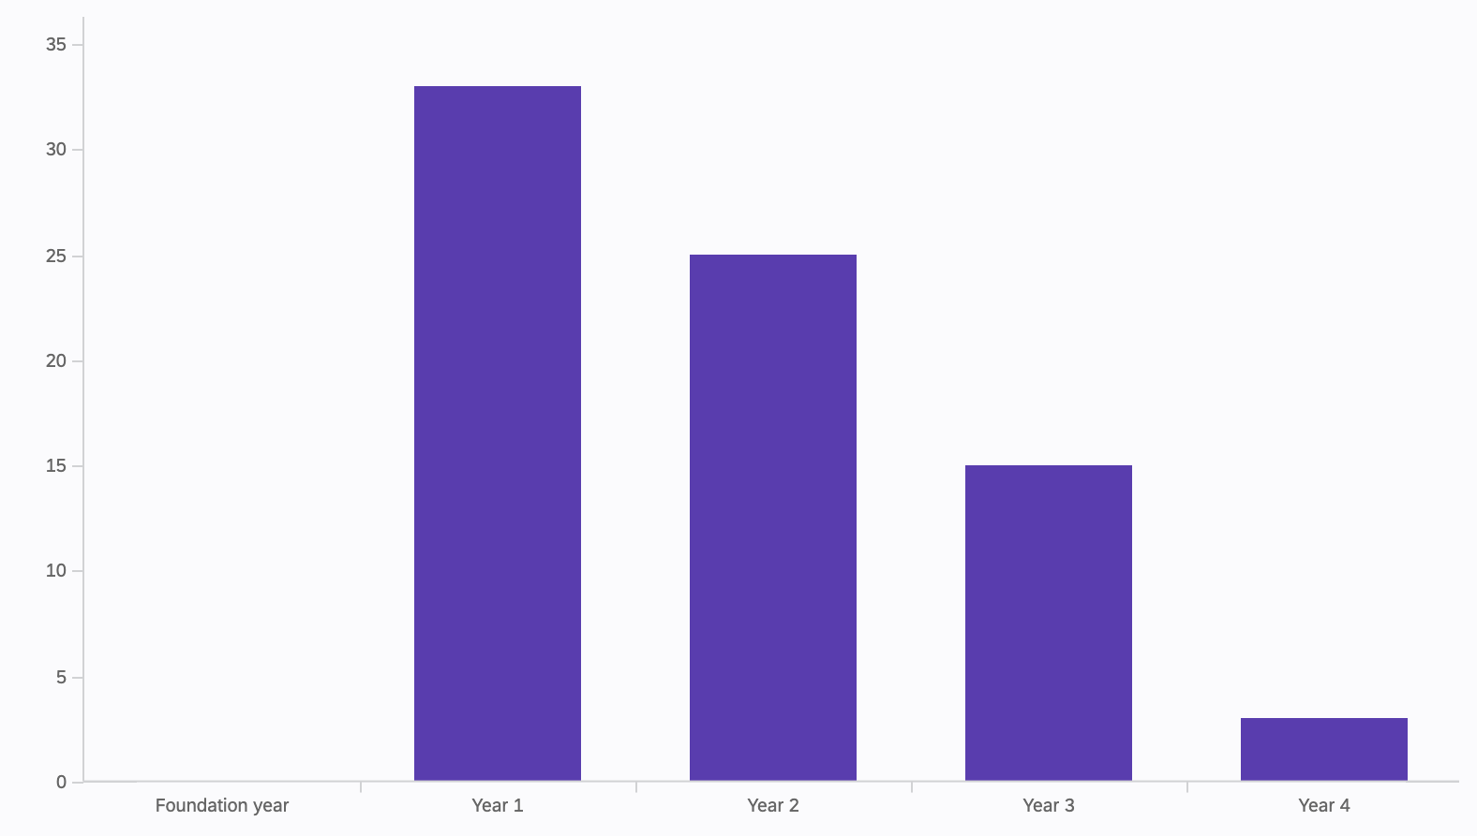
Degree programme
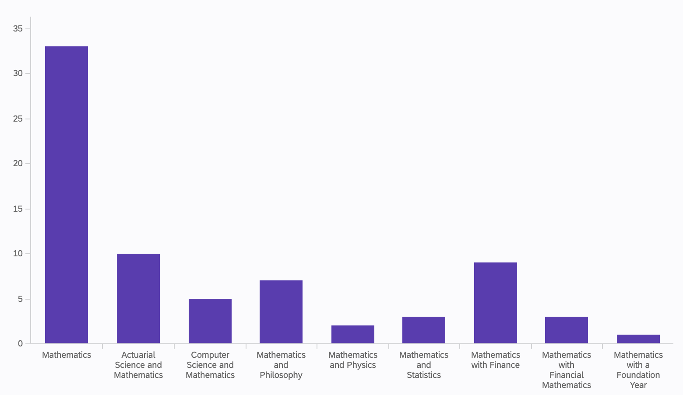
Current working grade
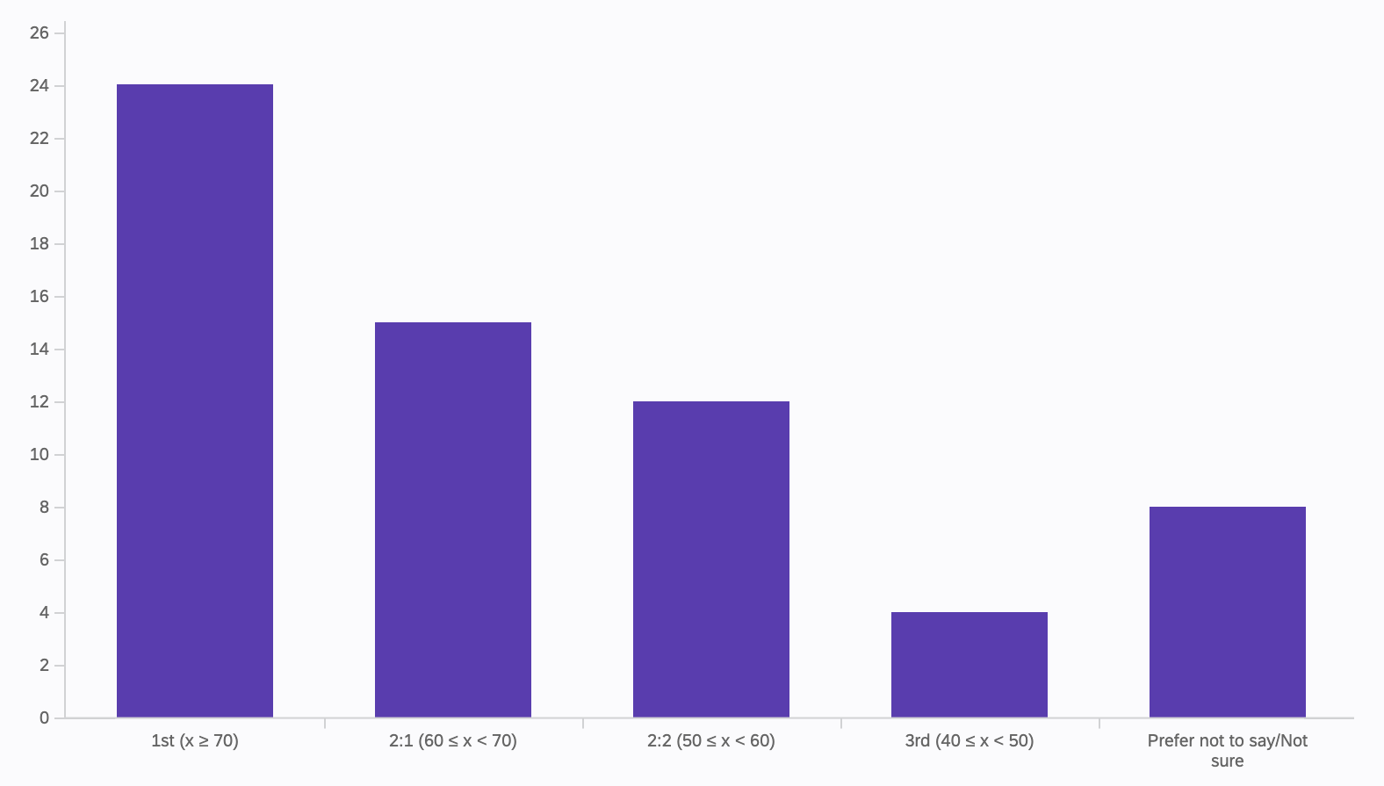

General student views on a variety of different sources of feedback

Q1: For each of the following sources of feedback, how much do you use them?

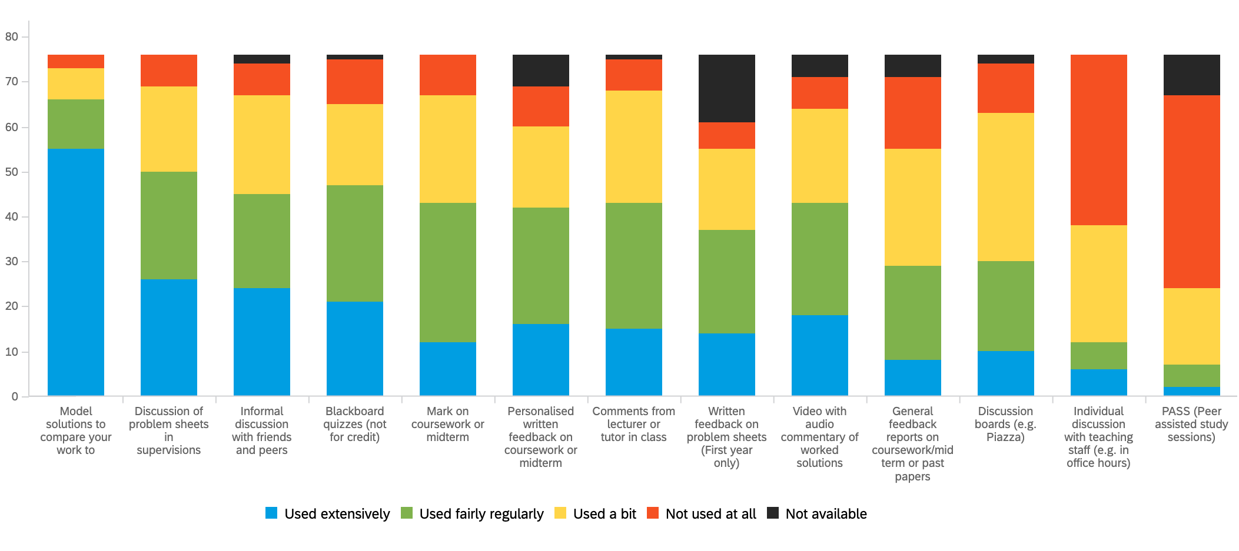

Q2: For each of the following sources of feedback, please rate the quality of the feedback you received.

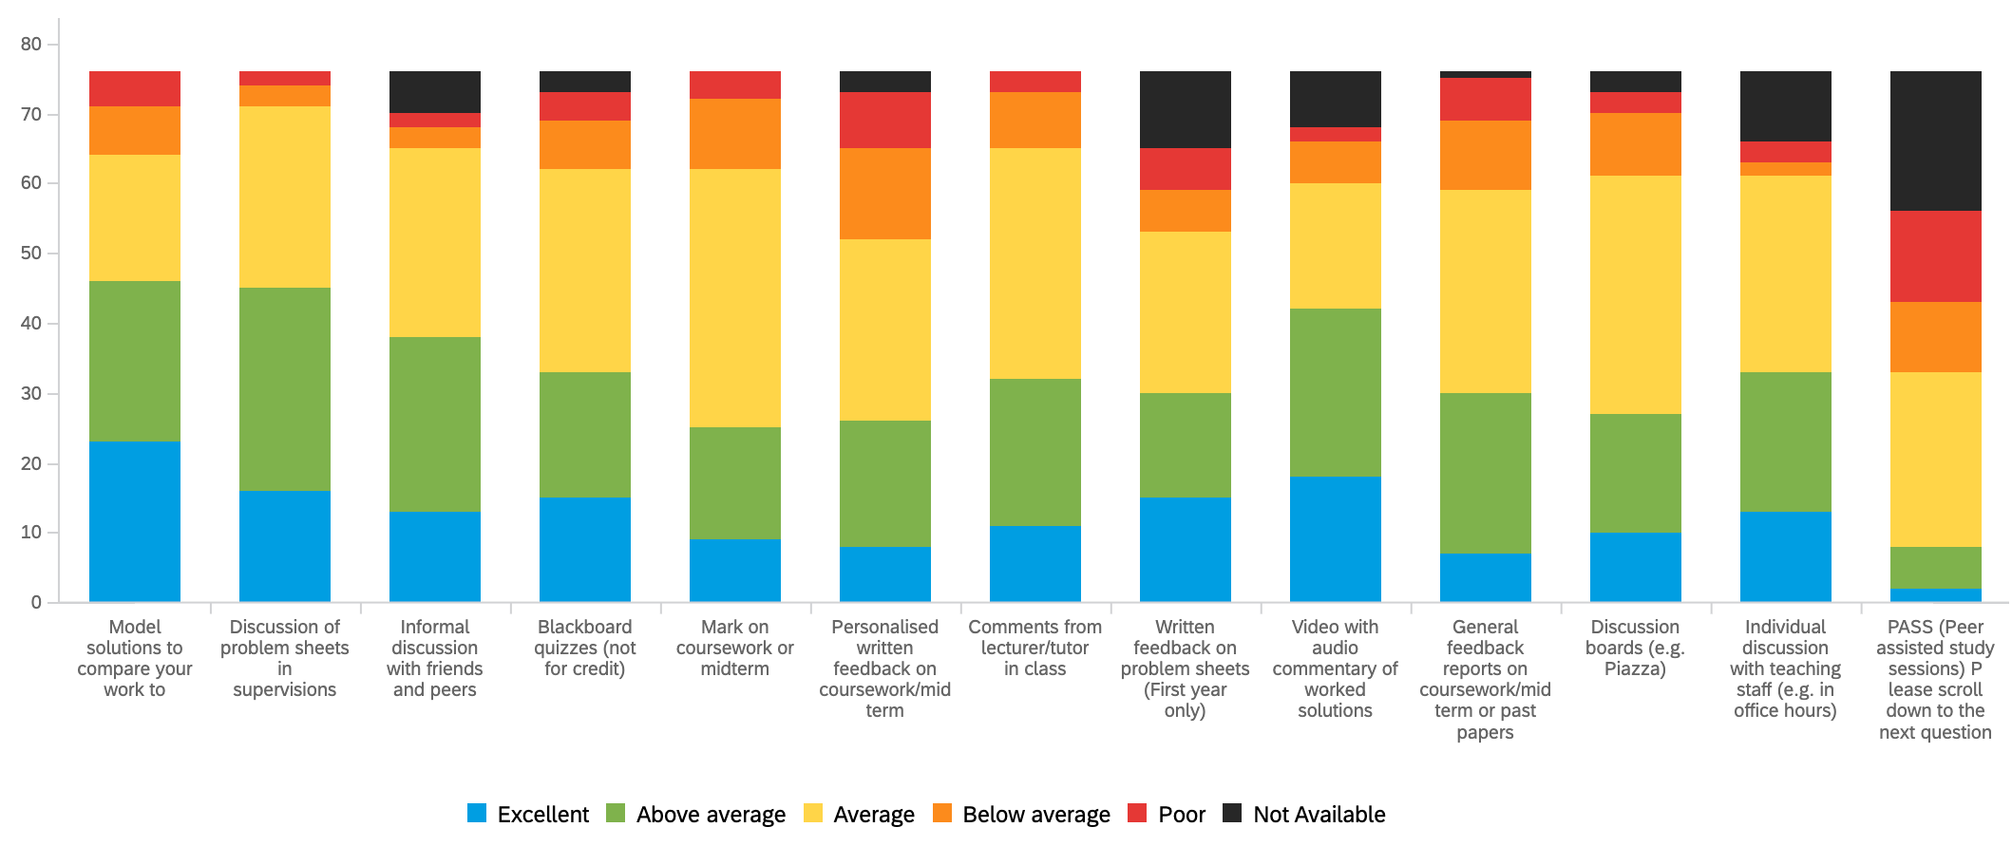

Q3 & Q4: Written responses of positive and negative views of different sources of feedback

Questions 3 & 4 asked students to elaborate on why they chose to rate some sources of feedback particularly positively and negatively. A selection of their responses is presented below, and represent a wide variety of views which reflect how diverse the learning styles and preferences of different students can be. The quantity of written responses, both positive and negative, should be interpreted alongside the statistics above when considering whether surveyees perspective on certain forms of feedback is generally positive or negative. The following responses should illustrate what aspects of feedback students find useful and not useful, in which areas they want to see improvement, and their reasoning behind these views. There are many instances of contradictory answers from different students, which only further demonstrates the importance of students being able to access a wide variety of sources of feedback to complement their own learning methods.

Later survey questions asked students for further information about office hours and model solutions, which we identified as areas of particular interest when designing the survey. Results concerning these two key sources of feedback will be developed in further detail below.

Piazza
- “Piazza was very useful for having specific questions that come up when studying answered.”
- “Piazza can be fantastic when participation is high.”
- “Many maths modules use Blackboard discussion boards instead of Piazza, which is very clunky and non-collaborative (also impossible to search on)”
- “With Piazza questions often remain unanswered a long time for some modules, and additionally it can get very busy with posts and hard to navigate to find particular topics within it.”
- “Some courses had lecturers who were particularly slow to reply on Piazza. It’s fairly understandable though, if you’re desperate go and ask someone in person.”
- “Discussion board questions are often left unanswered.”
- “People aren't very engaged on the discussion boards.”

PASS
- “PASS is a great idea on paper and some of my peers have told me of great experience so maybe it depends on your group, but my leaders were just so whack they literally didn't care or engage with us at all so everyone just stopped going.”
- “The PASS sessions I have attended I have felt were not a valuable use of my time, and so I stopped attending.”
- “I just didn't think anything we learned was difficult enough to warrant this kind of support.”
- “No one including leaders turned up.”

Blackboard Quizzes
- “I can go over the quiz over and over again and that helped me memorize some content”
- “Regular blackboard quizzes are very helpful for knowledge recall and to highlight key points from the week's topics.”
- “Blackboard quizzes are great for checking your understanding of how to approach and what to expect of the exams”
- “Blackboard quizzes should be provided for more courses.”
- “If there’s practice quizzes for a module these are really helpful but particularly when there’s full solutions for the questions.”
- “Blackboard quizzes often do not show the correct answer, or if they do they do not provide any explanations as to why that is the correct answer.”
- “Blackboard quizzes are not something that are available in the majority of maths modules, I have found.”
- “More often than not the quizzes didn't reflect real questions you would be given in exams and were extremely trivial questions.”

Peers
- “Talking to peers is the most effective form of feedback as it is readily available and gets quick answers.”
- “Informal discussions with friends was helpful since it’s a more relaxed environment where they are in the same situation as you, so you feel free to speak as you like.”
- “Overall any discussions about any question is helpful because it helps you see other people's perspectives.”
- “I don’t talk to my peers from my lectures and tutorials, since I don’t really have friends like that in my cohort. I have acquaintances though.”

Written feedback & marks on coursework, midterms and problem sheets
- “In my first year supervision classes, my supervisor's feedback was quite detailed and scrupulous which helped me immensely improve my mathematics writing skills.”
- “Written feedback on tutorial sheets is particularly useful for proof based questions because sometime you can have the general gist but may not have conveyed you’re ideas clearly enough which isn’t always obvious from the tutorial sheet.”
- “Written feedback on any coursework/problem sheets/midterms anything like that has always been extremely brief, the most I ever got was two words, 'good work' but usually it's just ticks or crosses.”
- “Having personalised feedback on coursework is useful because it helps you to focus on your weaknesses and work on them during the rest of the semester.”
- “Personalized feedback from coursework/midterms are often extremely poor, with one word explanations, and sometimes without reasons for why particular questions were graded as they were. In larger modules, it's also extremely dependent on the marker.”
- “Marks should be combined with a specific reason for the deduction of points, otherwise it does not let me know exactly what went wrong.”
- “When I get a question wrong, I tend to just be told it’s wrong or to try a different method without explanation of why my answer is wrong. This doesn’t help my learning or understanding, it usually just leaves me more confused as to what I’ve done wrong. It would be useful to get actual detailed personalised comments about how to improve work and not just stating that it’s wrong.”
- “Midterm/coursework feedback I found would be better if it were a bit more in depth, I found that more often than not I'd only get a sentence or two.”

Videos & worked solutions
- “Worked examples are the best thing ever”
- “Video solutions are good because you can watch slowly, go back, pause and compare your answer and really understand what's happening.”
- “Videos have no time restrictions when going through them.”
- “I also have found video recordings explaining the thought process behind the solutions very helpful.”
- “Often examples in lectures or videos are very basic and nothing like an exam question and it’s assumed we can make the jump from the example to the exam question completely independently.”

Supervisions & Tutorials
- “The supervisions helped a lot to clarify anything I didn't understand when doing the work on my own.”
- “Speaking to a tutor who knows the problems you will encounter in your problem solving techniques helps a lot.”
- “Supervisions may be not engaging if you got the homework correct, maybe more helpful to go through harder questions/ask the class for questions with supervisor to get more support for those.”
- “Supervisions were often overrun by one person and we watched a 1 on 1 with no chance to ask our own questions.”

General exam feedback
- “General feedback on coursework is useful as I can see where students make mistakes the most, and get a feel of how I compare to the rest.”
- “Sometimes the generic feedback they provide instead of solutions isn't useful as it tells you how the question was done wrong.”

Lecture Notes & written resources
- “I loved that the lecture notes were complete”
- “[A specific module’s] course notes had a large number of misprints to the point it was quite jarring. I would say I saw at least 15 errors and that’s just the ones I noticed.”
- “Consider changing some teaching styles. Specifically no notes, no videos, learn from the board style lectures. This style of teaching completely undermines those that are unable to attend for personal reasons, or those who may lose possession of notes for whatever reason.”

Office hours

Students who mentioned office hours as a particularly positive source of feedback (Q3) had complementary things to say:
- “Office hours can be excellent because it involves back and forth discussion: the lecturer can ask questions to the student to guide them through thought processes and the student can ask questions to the lecturer to clarify anything they don't understand.”
- “For individual discussions with lecturers, you are able to receive the specific feedback/insight that you require. This opportunity for back and forth discussion is something that there often is not time for in lectures or supervisions.”
- “Office hours were particularly useful since you'd get to focus on [your] concern and hone in on that.”
- “I rate the vigilance of my lecturers to help and answer questions most highly. Very inspirational people.”
- “Lecturers eager to help if we go to office hours.”

While no students highlighted any specific negative aspects of office hours, there were some answers which suggested a lack of student awareness or accessibility of office hours:
- “If staff was more available it would be easier”
- “The impersonal learning side can be tricky when you don't understand a concept and there is no one to explain it.”

This fits into a wider theme raised in survey responses about struggling with impersonal learning, and is reflected in the many responses asking for more personalised feedback

Q10: How often do you go to staff office hours?

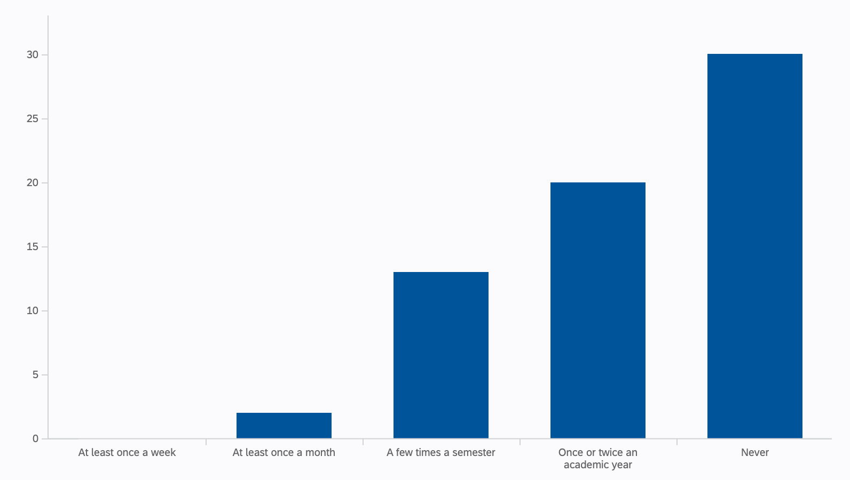

When specifically asked about office hours attendance, responses reflected what is already a common consensus: that office hours are a fairly underused resource with “Never” being the most common response. However, in response to this question, still a majority of students (n=35 of 65, 54%) said that they used office hours at least once an academic year, although earlier in the survey 49% of students said that they used office hours “Not at all”. (These statistics only include data from students who answered both questions.)

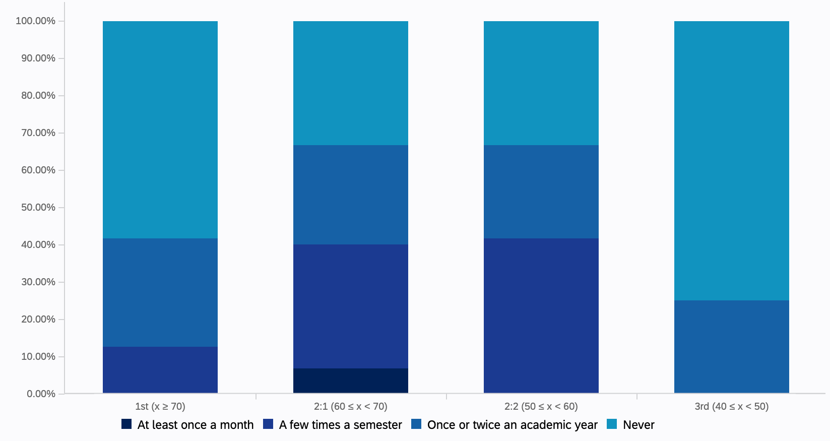

A grade breakdown of responses to this question shows that the surveyed students in middle grade bands (2:1 and 2:2) attend office hours more often.

Q10 Continued: Do any of the following make you less likely to go to office hours? (Check all that apply)

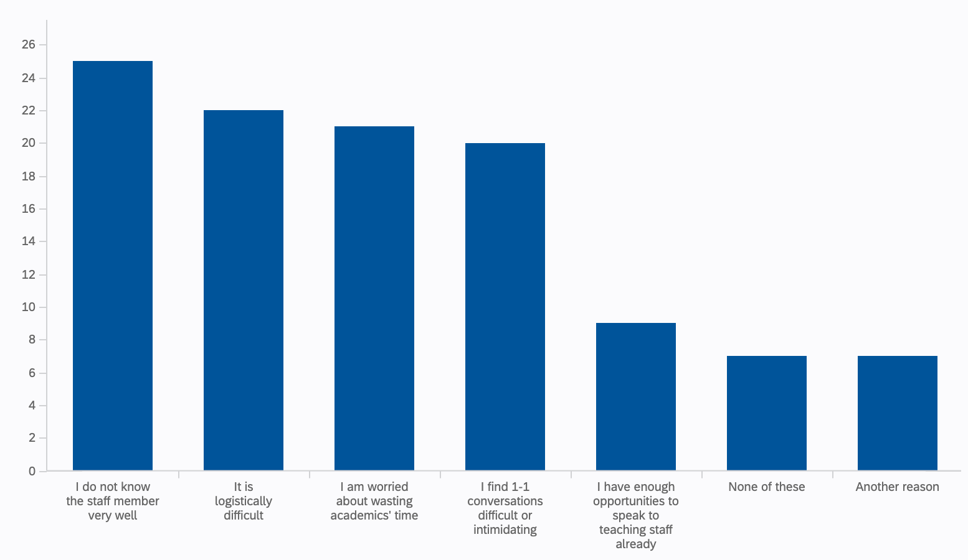

Students who responded “Once or twice an academic year” or “Never” were asked about their reasoning behind their frequency of visits to office hours, the results of which can be seen above. Some students who selected “Another reason” elaborated on this choice:
- “I feel silly asking questions if I think they are obvious, I don’t want to be judged or create a bad image for myself.”
- “I have childcare commitments and the timetable layout is hard enough covering lectures/mandatory sessions”
- “Sometimes if you don't have a specific question about something […] it's more of a general lack of knowledge so I would go if I had something specific to clarify”
- “I find it hard to think of ‘proper questions’ to ask. I don't feel like I can just turn up and ask to talk about a particular concept I don't understand without having a specific question e.g. asking a specific thing about [a specific theorem] rather than being able to just talk about the theorem for a bit.”

Model solutions
Out of all the different types of feedback which students were asked to rate, model solutions were (perhaps unsurprisingly) overwhelmingly marked as “used extensively” by 72% (n=55) of responses, with only 4% (n=3) answering “not at all”.

When asked about quality, 61% (n=46) of responses rated the quality of model solutions in equal parts as “above average” (n=23) or “excellent” (n=23).

As can be seen below, students generally feel confident with self-evaluation, even more so when they are using model solutions with 84% (n=53) responses in agreement with the statement “I feel confident using model solutions to evaluate my work independently”.

Q14.1-3: Please indicate your agreement with the statements

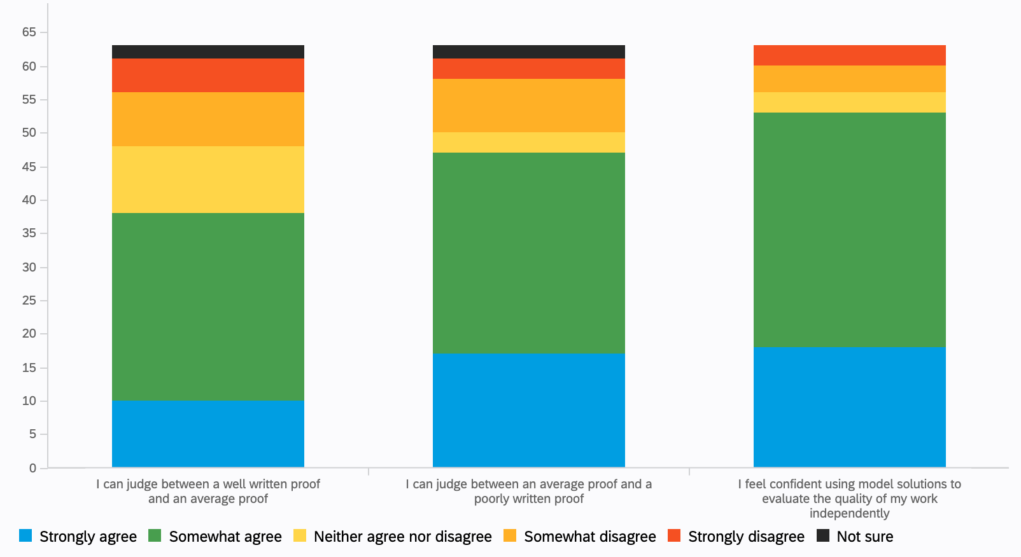

Q12: How often do you feel confident judging the quality of your work without help from staff or peers?

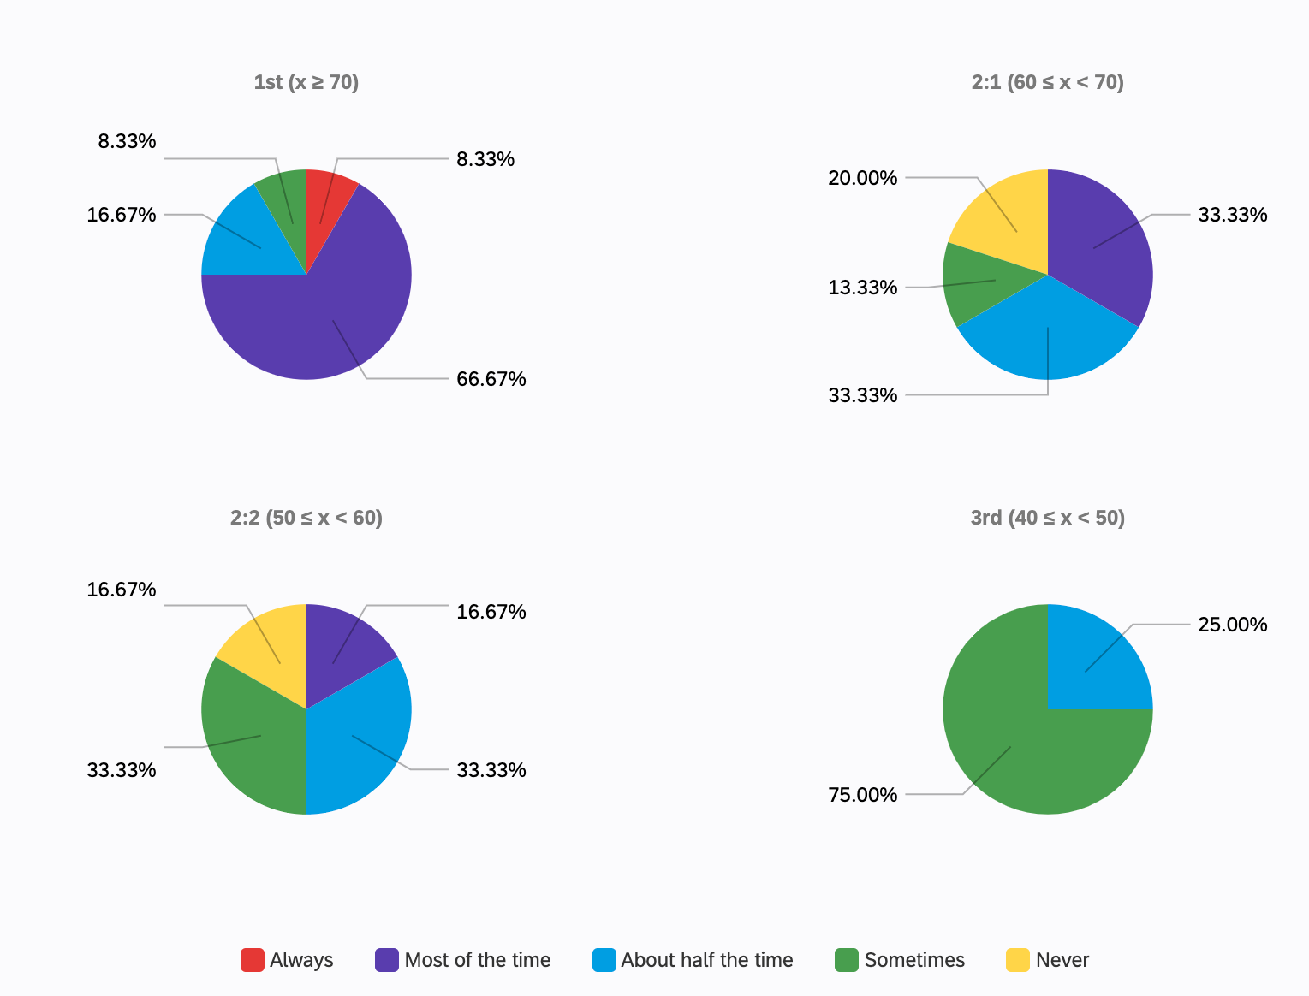
As expected, survey responses indicate that students with higher grades have more confidence self-assessing their work than those with lower grades, which is interesting to consider alongside how students with different grades feel about model solutions and when they should be released.

When asked to elaborate on the positives of their choices of feedback, students who mentioned model solutions gave a variety of different reasons for why they found model solutions so helpful, including reasons of reviewing exam technique, individual study habits and preferences, convenience and multiple mentions of seeing the “thought process” behind a question.

- “The model solutions served as a great framework for presenting my answers in the right manner and with adequate detail”
- “Model answers help to see how much detail is expected so it helps to prepare for exams.”
- “Having model solutions or instructional videos allows me to quickly clarify a small issue I may have with a question without having to go far out of my way. As most the issues I have can be answered quickly and easily by seeing what someone else has done.”
- “Model solutions are most useful since not all questions are covered in supervisions and show us how to structure answers. Model answers are often detailed and prompt further questions to ask on discussion boards etc.”
- “Videos and model solutions have no time restrictions when going through them”
- “Having model solutions to questions is very useful because it allows me to compare answers and see the thought process of the lecturer.”
- “I also have found model solutions as well as video recordings explaining the thought process behind the solutions very helpful.”

The students who gave feedback about what could be improved about model solutions generally referenced wanting more model solutions, wanting past papers to always come with solutions. One student gave their reasoning for this:
- “The past papers are often given without solutions so in the case that you’re struggling you feel very stuck and alternatively you could be repeatedly doing a question wrong but feeling confident with it because you have no way of checking if what you’re doing is right.”

Some students gave feedback on how they feel model solutions could be improved:
- “Model solutions could be improved if they either didn't skip intermediate steps, or explain in written words how they moved from step to the next.”
- “About some solutions the process could be more detailed, not only the answer”

Q13: Regarding problem sheets which you are expected to mark yourself using model solutions, when would you prefer the solutions to be released?

Responses were mixed. In general, it seems students would like there to be a delay between the release of problem sheets and their solutions, although this varies between years and there are mixed views of whether solutions should come before or after a tutorial corresponding to the material.

Students were offered a few options, including “Towards the end of the course, just before the exam”. No students selected this option, which can be seen in the representation of the overall responses, but not in the break downs by year group or grade.

The “Other” option was chosen by two students:
- “It makes no difference to me.”
- “At least before the tutorial so you have time to mark your work and see what you need to discuss with your tutor, otherwise if it's released after the tutorial for that content, then the class has already moved on so it's not productive to focus on last week's and current weeks content.”

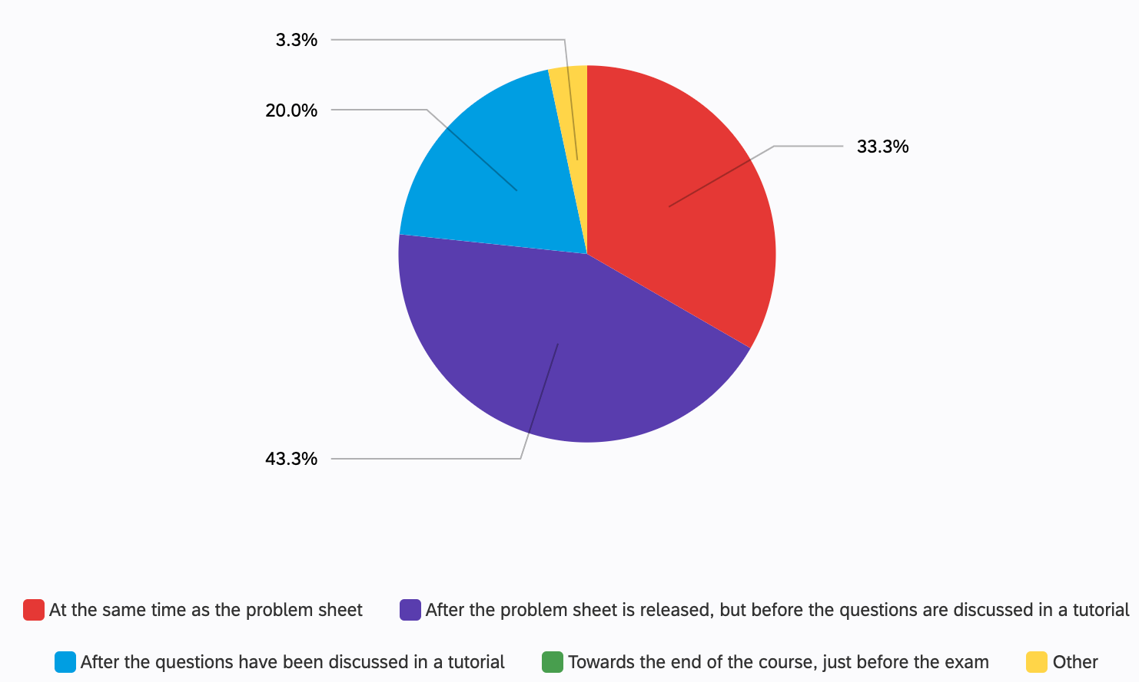

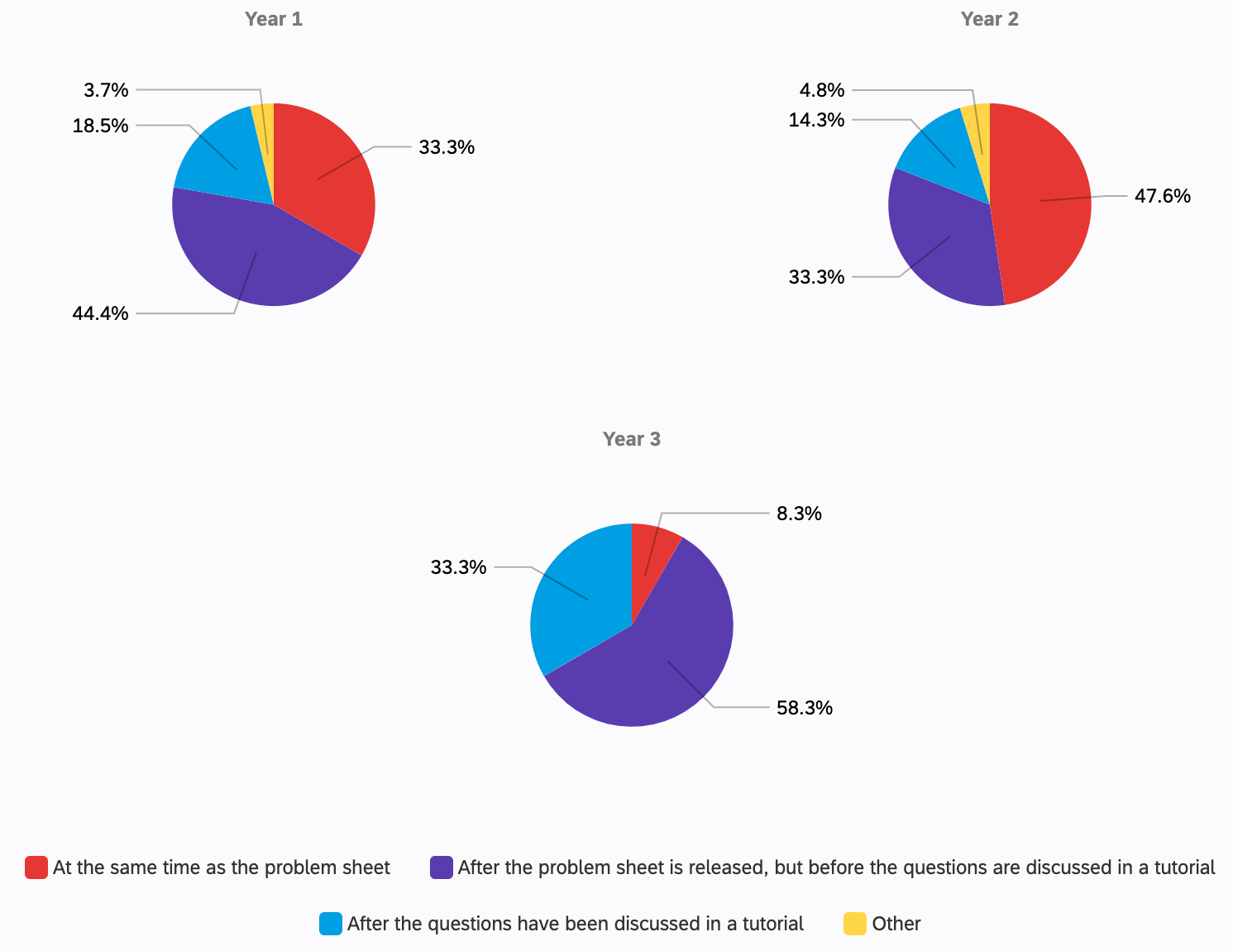

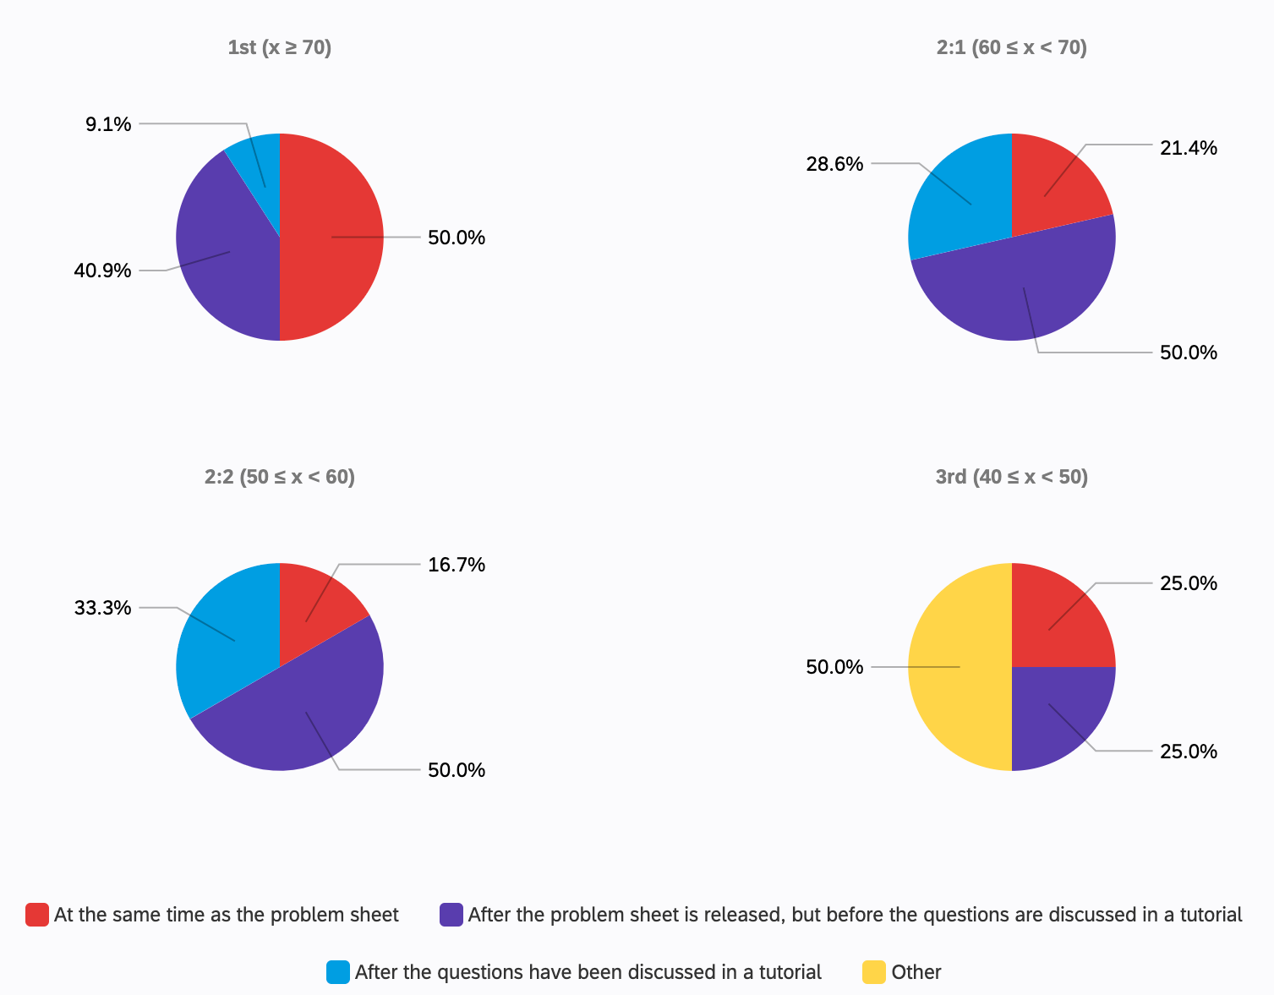
A slight trend can be seen when comparing the responses of students in different degree classes, with more students with higher grades preferring solutions to be available earlier and students with lower grades preferring more of a delay in the release of solutions.

When asked about how the impact feedback can have on emotional wellbeing and mental health, the students who mentioned model solutions had some differing viewpoints. Generally, most respondents who said that feedback impacted their emotional wellbeing (as opposed to many students, who said that their emotional wellbeing was unaffected by feedback) referenced frustration when they got something wrong but felt they had insufficient feedback to correct it. One student responded
- “When you do a midterm and you receive a bad grade but have no solutions it can be overwhelming, especially in the cases where there are no similar questions in the lecture notes or example sheets.”

However, another student referenced an overemphasis on model solutions without alternative feedback channels as a source of frustration:
- “I find it really frustrating when I’m just told to look at the model solutions or to try a different method without someone explaining why my method doesn’t work or where specifically I have gone wrong.”

Emotional wellbeing and mental health

Q16: In general, how often does the feedback you receive make you feel motivated to improve?

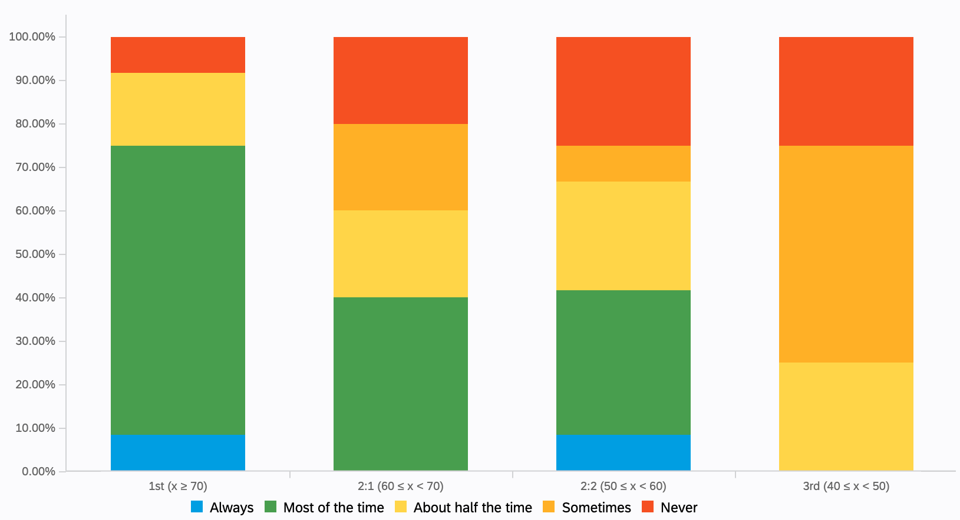

Survey responses from students in lower degree classes say that feedback is less likely to make them feel motivated to improve. However, caution should be taken when attaching too much significance to the lowest grades, due to small number of responses (n=4) from students with a working grade of a 3rd.

Q17: How does the feedback you receive impact your emotional wellbeing and mental health? Is there anything we can do to improve this?

Several students responded that their mental wellbeing is unaffected by feedback. There were quite a few responses which were variations on “It doesn’t affect my mental health”.
- “The feedback I receive has a very minor impact on my mental health; I often know how well I did before the feedback comes in.”

Other responses to this question highlighted only the positives of receiving feedback:
- “In general feedback feels constructive so it does not make me feel negatively.”
- “I want them to be as harsh as possible. Critique everything. Now isn't the time for holding my hand. Give me the facts please!”
- “I am eager to receive any feedback as I am always willing to learn from the expertise of the lecturers. I see their feedback as an opportunity to grow.”
- “Mostly positive, in general it’s not surprising. I know if I’ve got questions wrong before I've got feedback. The feedback then just helps me see why/where I went wrong.”

Although some students responded as above with a positive or neutral about how feedback can impact emotional wellbeing and mental health, the majority of responses highlighted the negative impact that feedback can have on them.

The most common theme highlighted by the responses was how low quantity, detail and timeliness of feedback can have a negative impact:
- “The feedback is minimal and so it's hard to improve from this.”
- “Receiving a low mark would naturally make most people upset, but this is greatly exacerbated by not seeing how you could improve your grades. I feel this applies to grades on the whole and study practices in particular.”
- “The quicker the feedback is given, the less time is spent thinking/worrying about it, and the more time there is to do something about any mistakes.”
- “It usually just makes me feel disheartened because the comments I get just point out the mistakes with no clear comments on how to actually improve. I find it really frustrating when I’m just told to look at the model solutions or to try a different method without someone explaining why my method doesn’t work or where specifically I have gone wrong. Learning brand new methods doesn’t help my understanding but learning from my mistakes does.”
- “Sometimes mistakes are simply pointed out with no extra feedback.”
- “When the feedback is not what I expect, sometimes I will feel worried. I hope that every time I get a grade, I can get a detailed explanation for the loss of mark.”

As expected, some students referenced the effect of receiving negative feedback:
- “Feel sad when I mess up some exercise but I think it is part of studying”
- “Some feedback was so negative, I stopped handing in my homework”
- “Sometimes I feel depressed if the feedback is negative, especially when it is far below my expectations.”
- “There are times when the score is a little different from what I expected and I get upset.”

Other notable responses to this question included:
- “As a joint hons student, I felt quite left out from maths circles, leaving me to feel like there was very little support available when I fell behind and more so because I was intimidated to ask lecturers questions about past content as I didn't know them.”
- “The feedback received doesn’t affect my wellbeing. If any aspect of my studies affects my wellbeing, it’s the stress involved, since I want to be doing my best. I am happy with my results up to now, but those results won’t mean much if I fail to ‘stick the landing’ in fourth year.”
- “In certain assessments such as group work, subjective comments diminish confidence in the way we have chosen to write. One writers preference may differ to another’s, however this shouldn’t be criticised.”

Some general feedback views

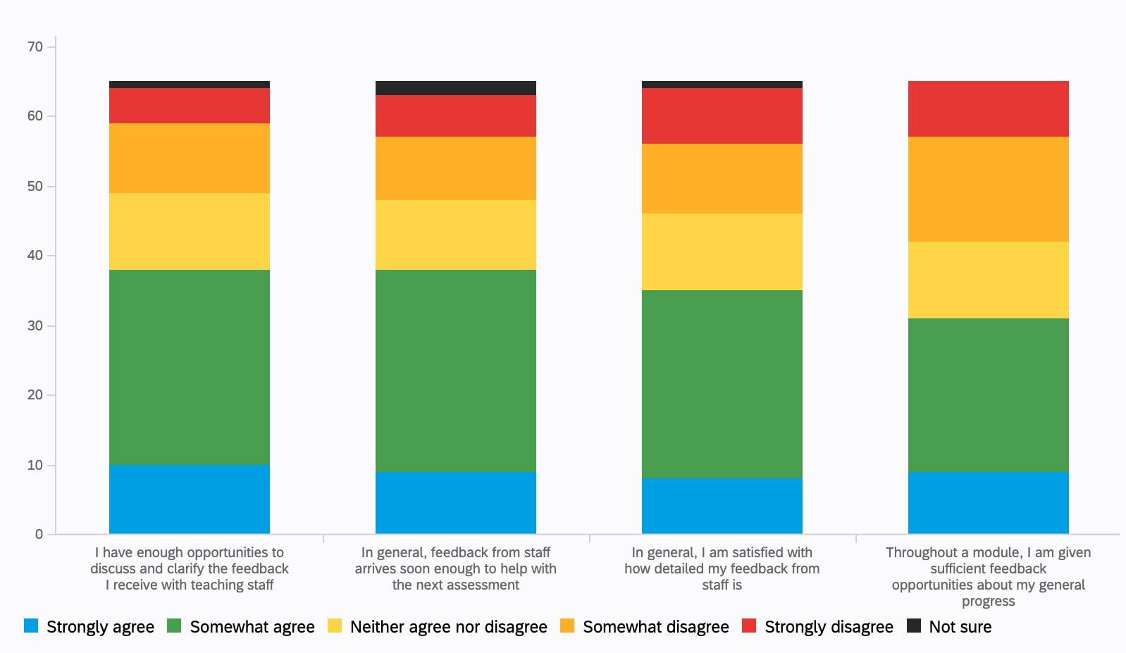

Q6.1: I have enough opportunities to discuss and clarify the feedback I receive with teaching staff
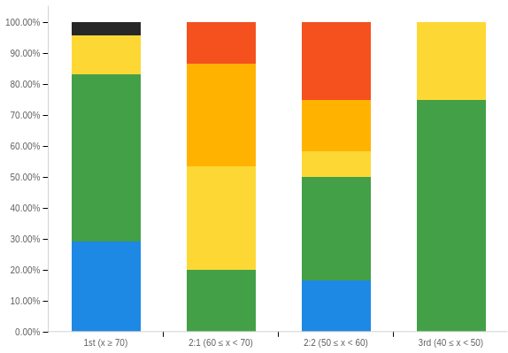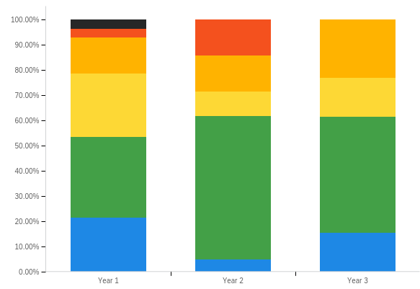

Q6.2: In general, feedback from staff arrives soon enough to help with the next assessment
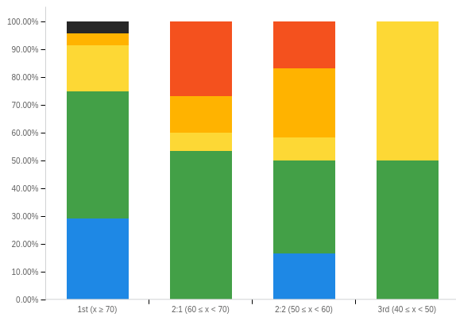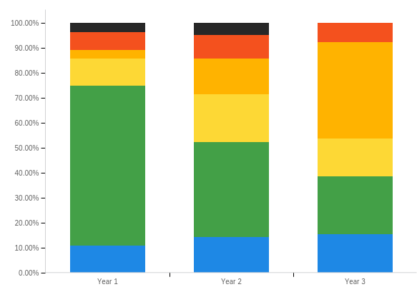

Q6.3: In general, I am satisfied with how detailed my feedback from staff is
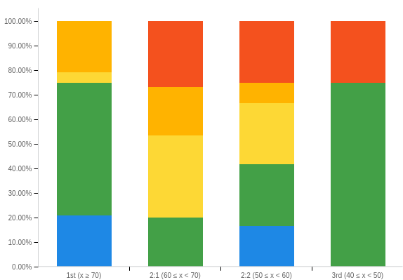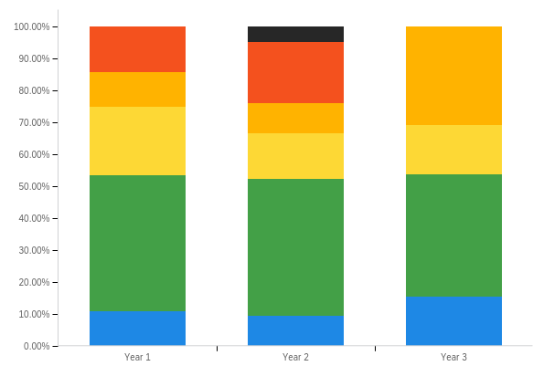

Q6.4: Throughout a module, I am given sufficient feedback opportunities about my general progress
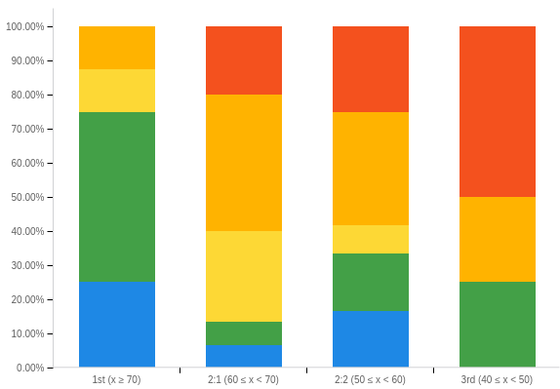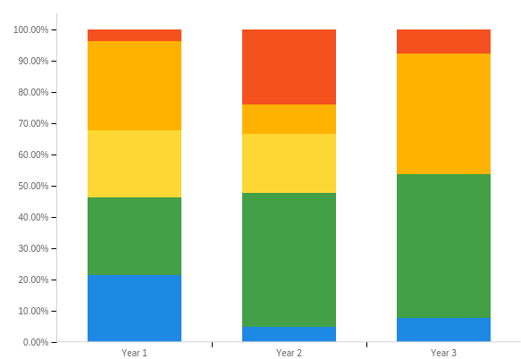

Q8: Under what circumstances are you likely to review written feedback?

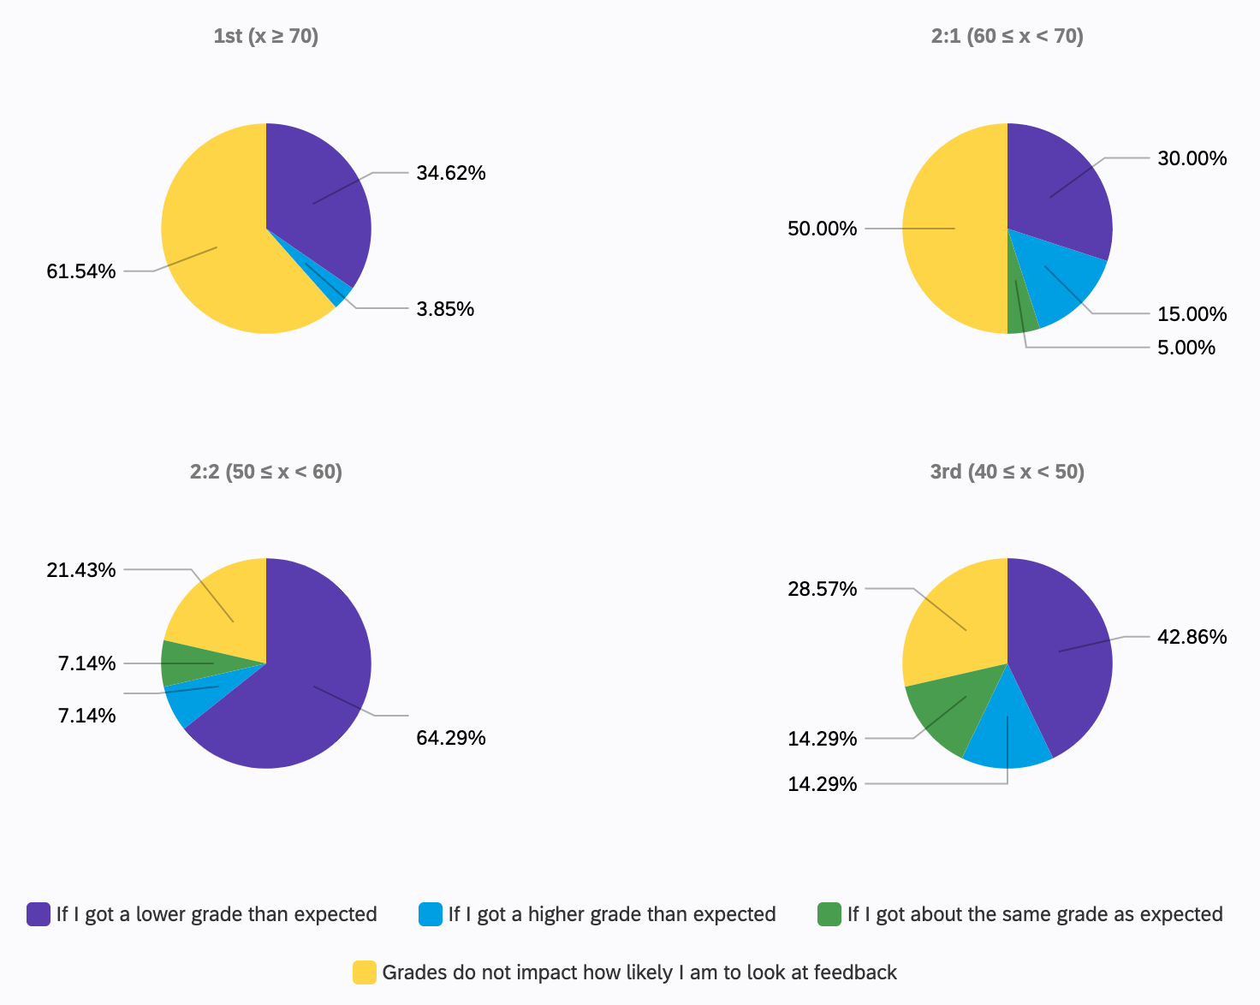

Q7: When you receive feedback from teaching staff, what do you find the most useful?

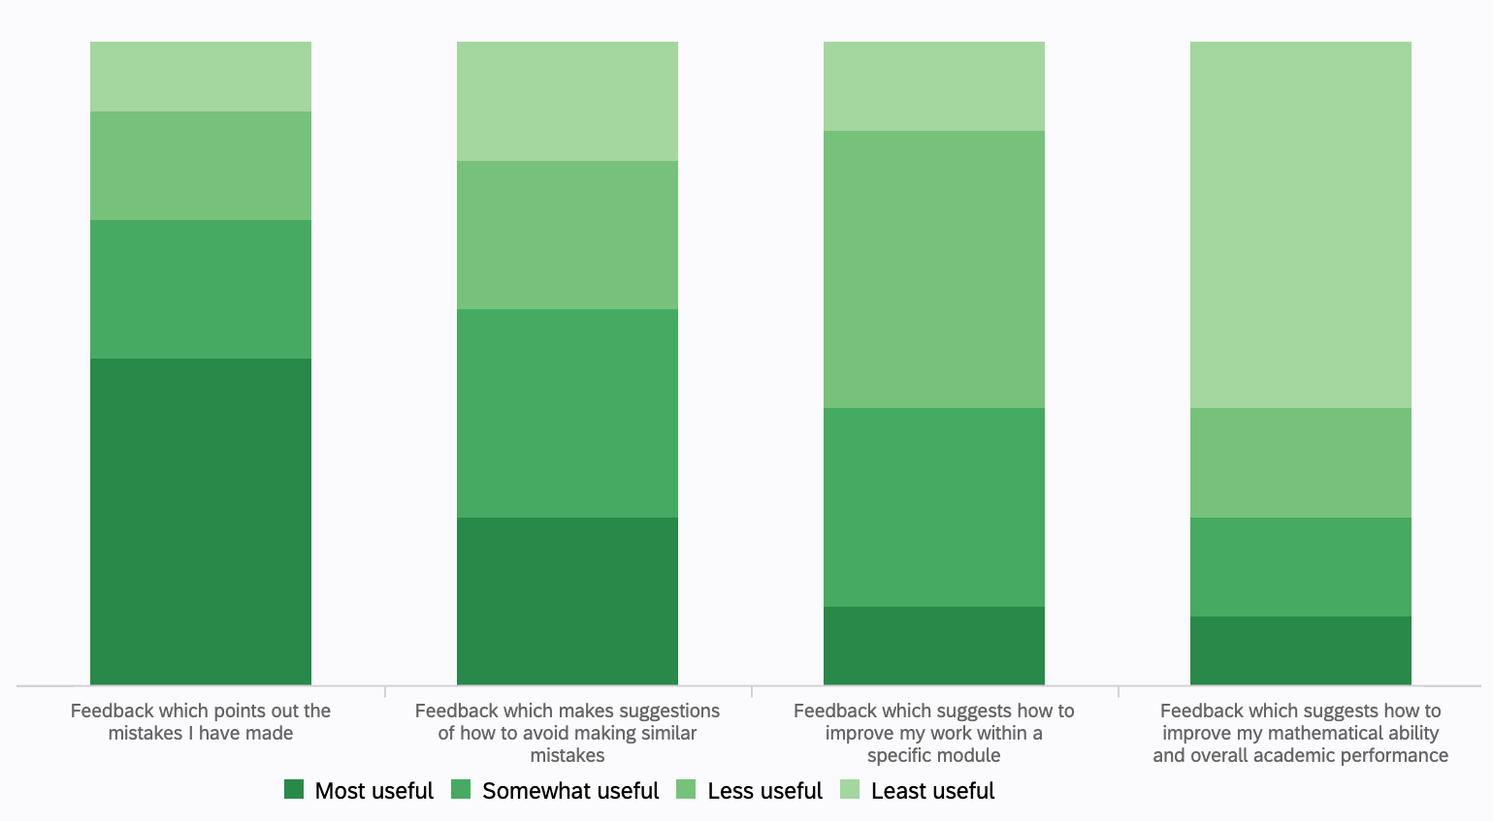

Q11: If you could improve some aspect of the feedback you receive, what would be the most important aspect to improve?

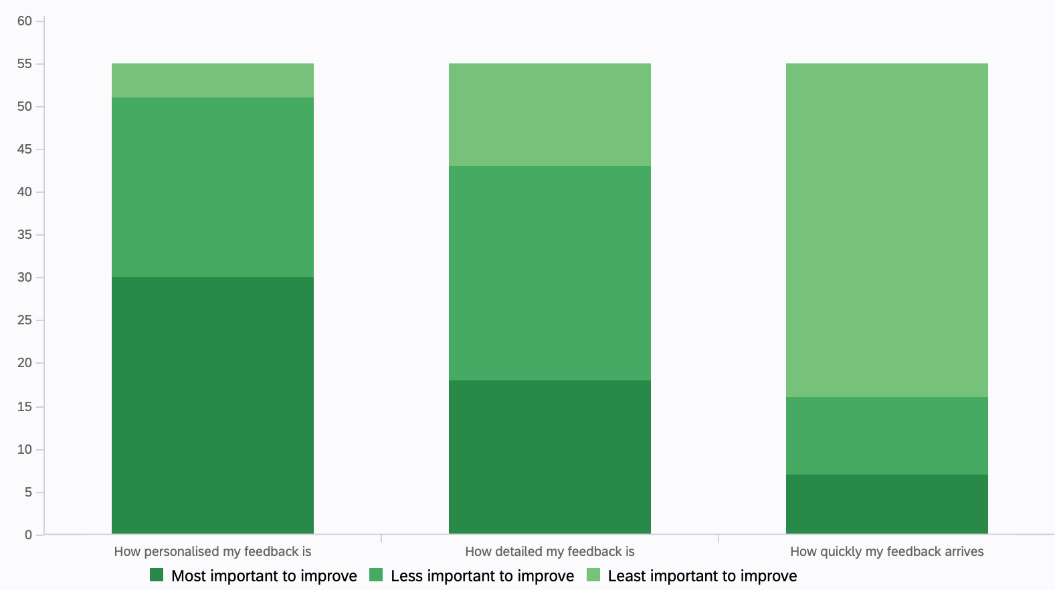

Note that for Q7 and Q11, surveyees were asked to drag and drop the options into order (most to least useful, most to least in need of improvement). The most frequent ordering is the same as the order the options were presented to the students in (in other words, the most common response to this question was to leave the options in the order they started in, which is the same as the order presented in the results above).

Q18: In general, is there anything more that we could do to improve your experience of assessment and feedback? Do you have any further comments relating to assessment and feedback?

The most common theme in the responses to this question emphasised the student desire for increased quantity of feedback, more personalised feedback, more detailed feedback and for feedback to be delivered faster. Most answers of this kind were general (e.g. “Increase the amount of feedback and also make it quicker”), but some students shared more specific opinions:
- “I have always really needed personalised detailed feedback to help me understand. Also when we have two courseworks for a module it is crucial to have feedback for the first one before taking the second so we can learn from mistakes and comments. Also not taking two months to mark one coursework which we only receive back less than a week before the final exam is quite important. If lecturers are struggling to keep on top of marking then the department should be finding other staff to help them and not just leave them to it because it hugely affects us as students.”
- “I do wish academic advisors would provide more feedback and advice about their students' studies generally.”
- “We need much more feedback on exam technique and the mark distribution, I’ve done a year so unsure of all of this.”
- “Make feedback more in depth and personalised, supervisors hardly are aware of the students they are teaching so it is tough to give personalised feedback however there could be an increase in the amount of quantity.”

Another common response to this question concerned past papers and solutions. One student went into detail about this:
- “With assessments, I would like to see a consistent rule on past papers and its solutions, i.e. all courses are required to provide at least 3 past exams (which are in a similar format to the one you will sit) with solutions. It's been a real problem this academic year with not having solutions to past papers in some courses, especially when the questions are very different to examples in lecture notes and tutorial sheet questions. Sometimes the generic feedback they provide instead of solutions isn't useful as it tells you how the question was done wrong. In some cases lecturers have refused to discuss past exam questions when the solutions are not provided meaning we cannot get any feedback.”

Some other interesting views shared by students include:
- “A choice of questions on the exam is nice, smaller workspaces in exams are a pain. Past papers are very useful. Generally, courses in later years have less of them.”
- “Don't let modules have a multiple choice quiz with only 2 question as a coursework counting 20%. That is does not give a fair representation of knowledge.”
- “I am a big fan of having many homeworks/courseworks throughout the semester.”
- “I've heard that sometimes coursework is not graded by one teacher, but by more than one teacher. I kind of wonder if the marking criteria is consistent.”
- “Make the assessment harder. The Linear Algebra exam was too easy and failed to let us demonstrate solving difficult problems. Everything was just a copy and paste of the most boring questions on weekly sheets.”
- “Cheat sheets in exams!! Don’t help too much but give a safety net to ensure I remember definitions and can focus on application.”

Concluding thoughts

Perhaps one of the most important results of the survey is how apparent the diversity of student views is. Many students offered contradictory views about assessment and feedback and every source of feedback discussed had students offering up both praise and suggesting areas of improvement. This suggests that a wide selection of feedback sources and resources is very beneficial for students, as it allows students to experiment and develop their own learning style which works for them, perhaps best summed up by one response to Q4:
“All resources were useful, but I found what worked best for me”

Unsurprisingly, responses strongly emphasised the general desire among students for increased feedback opportunities in quantity, quality, detail and personalisation. The mental wellbeing section on the survey revealed the anxieties students experience when receiving negative feedback while dealing with the frustration of not feeling like there are sufficient opportunities for them to understand exactly why their feedback is negative or what needs to be done to improve.

Many responses displayed awareness of the challenges faced by academic staff in meeting student expectations around feedback, acknowledging the difficulty of providing detailed, personalised feedback for a large undergraduate maths cohort.

Students were particularly overwhelmingly in agreement about the usefulness of opportunities to independently practice questions and mark their own work with model solutions. This was mentioned in a variety of contexts, with frequent mentions of generally wanting more worked examples, past papers and problem sheets.

“Since it is a Mathematics degree the sources of feedback which I find particularly important are those that allow practice/ trial and correction by students and comparing our work to model solutions.”

Students clearly see opportunities to practice their mathematics and mark their own work as an invaluable source of feedback, and increasing opportunities for students to do this may help to address the difficulties and frustrations caused by a feeling that feedback opportunities are limited, lacking detail or personalisation, or that the available feedback channels are not helping.

